Batch Analysis Pipeline for 4-Channel TIFF Images
Overview
This MATLAB pipeline performs batch analysis of four-channel TIFF images (e.g., STED or confocal datasets).
For each selected image, the script generates a comprehensive set of visualization figures and quantitative overlap coefficients, and exports all numerical results into a single CSV file for downstream statistical analysis.
The pipeline is fully automated, requires no manual ROI selection, and is designed to ensure reproducibility and consistency across large datasets.

Input Requirements
- Multi-page TIFF files with at least four image planes
- Channel assignment:
  - Channel 1: Red
  - Channel 2: Green
  - Channel 3: Blue
  - Channel 4: Gray (displayed as intensity added to RGB channels)
All images are assumed to be aligned and of identical dimensions across channels.

How to Run the Analysis
- Open MATLAB and add the script directory to the MATLAB path.
- Run the main batch function:
- batch_analyze_4ch_tiffs2
- A file selection dialog will appear.
Select one or multiple 4-channel TIFF files.
- The script will process each file sequentially and report progress in the MATLAB Command Window.
Each image is analyzed independently; if one file fails, the remaining files will continue to be processed.

Output Summary
For each TIFF file, the following outputs are generated:
Figures (saved as .fig files)
- Fig1–Fig3: Combined into a single main figure
- Fig4: Pairwise channel overlap analysis
- Fig5: Triple-channel overlap analysis
Figures are saved in the same directory as the input TIFF file, using the original filename as a prefix.
Numerical Results
- All overlap coefficients are aggregated into a table
- A timestamped CSV file is saved in the same directory
- The results table is also assigned to the MATLAB base workspace as:
- batch_overlap_results

Figure Descriptions
Fig1 — Original Normalized Images
Each channel is independently normalized to the range $\left[0 , 1\right]$using linear scaling.
Merged RGB images are generated to visualize pairwise and multi-channel combinations.
Purpose
- To inspect raw intensity distributions
- To provide a reference view independent of contrast enhancement or thresholding
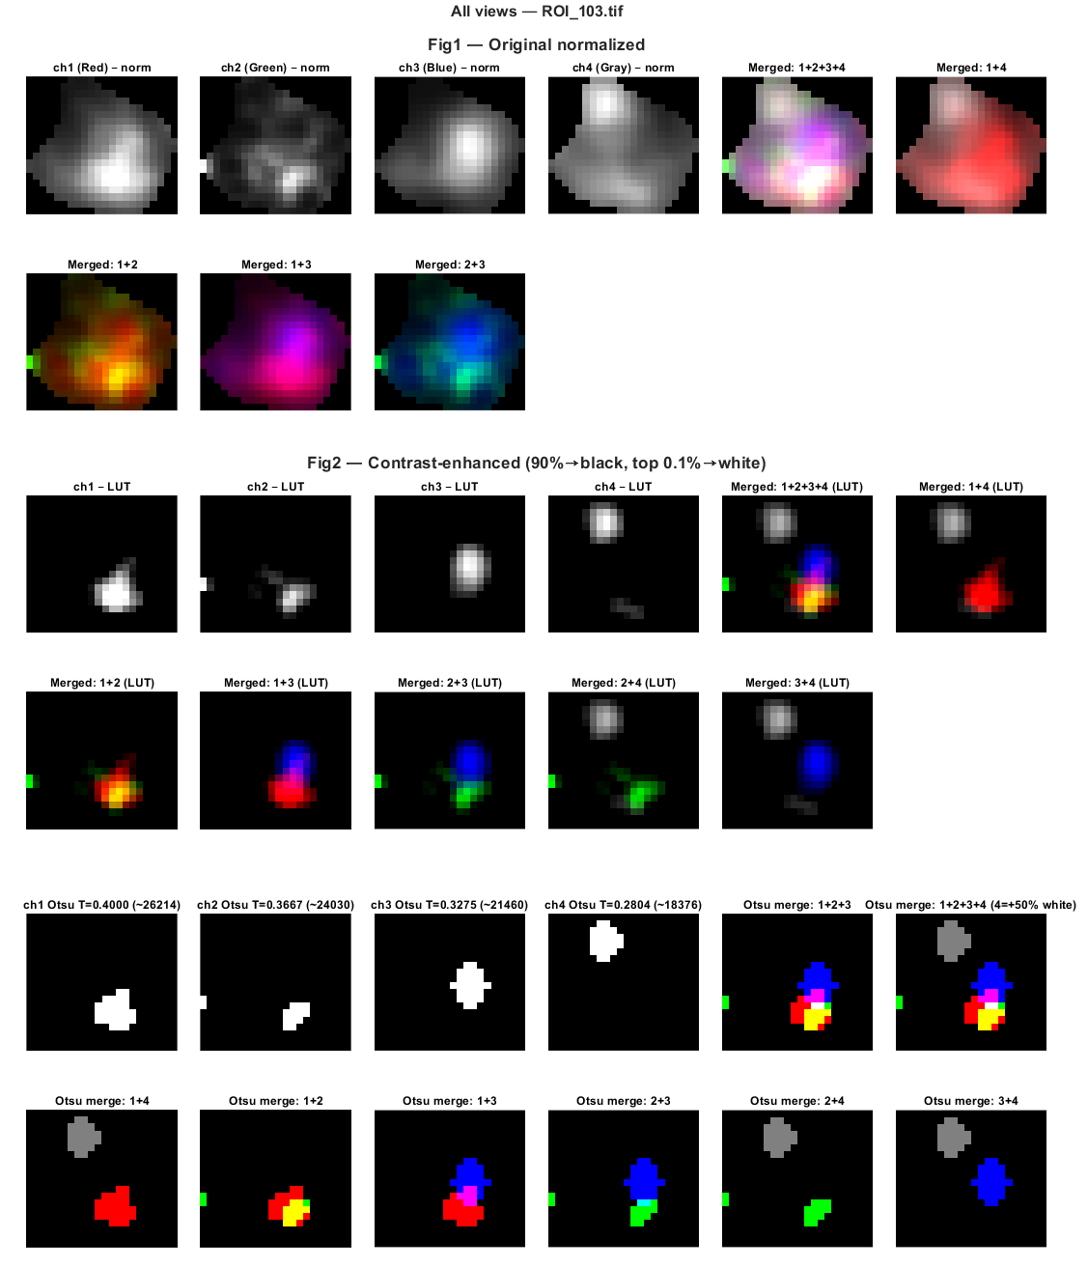
Fig2 — Contrast-Enhanced (LUT-Applied) Images
A percentile-based LUT is applied to each channel:
- Intensities below the 90th percentile are mapped to black
- Intensities at or above the 99.9th percentile are mapped to white
- Intermediate values are linearly scaled
The original 16-bit dynamic range is preserved during processing before display.
Purpose
- To enhance weak structures
- To approximate manual LUT adjustments commonly performed in ImageJ/Fiji
- To standardize contrast across datasets

Fig3 — Otsu Thresholded Binary Images
Otsu’s method is applied to the LUT-enhanced images to generate binary masks for each channel.
Merged pseudocolor images illustrate spatial overlap of thresholded signals.
The fourth (gray) channel is displayed as a white intensity overlay.
Purpose
- To visualize automatic thresholding results
- To compare intensity-based and structure-based representations
- To assess the upper bound of detectable overlap
[Figure 3 placeholder]

Fig4 — Pairwise Overlap Analysis
All six pairwise channel combinations are analyzed:
- ch1–ch2
- ch1–ch3
- ch2–ch3
- ch1–ch4
- ch2–ch4
- ch3–ch4
For each pair, a row of panels displays:
- Merged LUT-enhanced image
- Normalized channel A
- Normalized channel B
- Pixel-wise overlap map with overlap coefficient
Purpose
- To visualize spatial overlap
- To quantify pairwise colocalization using a consistent definition
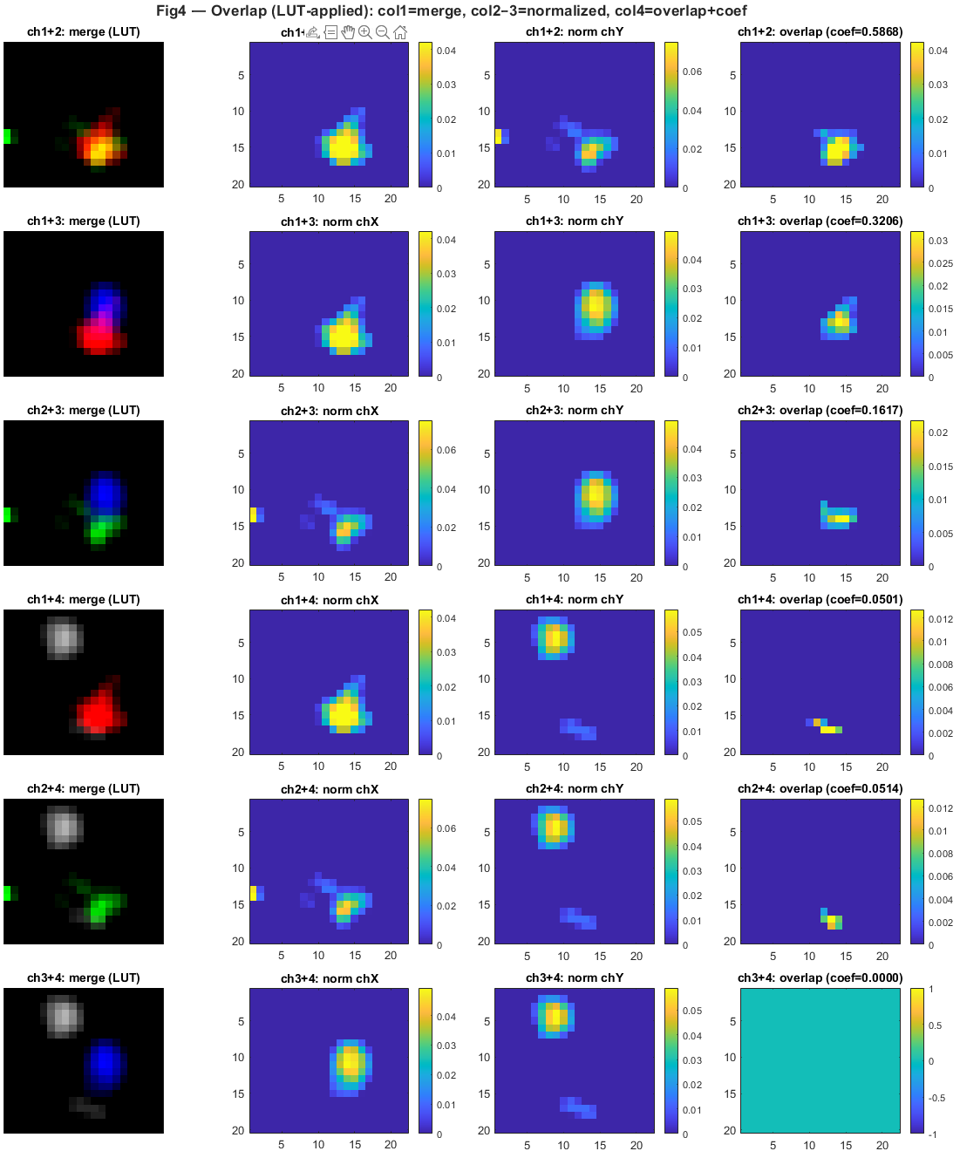
Fig5 — Triple-Channel Overlap Analysis
All four triple-channel combinations are analyzed:
- ch1–ch2–ch3
- ch1–ch2–ch4
- ch1–ch3–ch4
- ch2–ch3–ch4
Overlap is computed as the pixel-wise minimum intensity across three normalized channels.
Each row displays:
- Merged LUT-enhanced image
2–4. Normalized individual channels
- Triple-overlap map with overlap coefficient
Purpose
- To quantify higher-order colocalization
- To identify regions where three molecular components co-exist
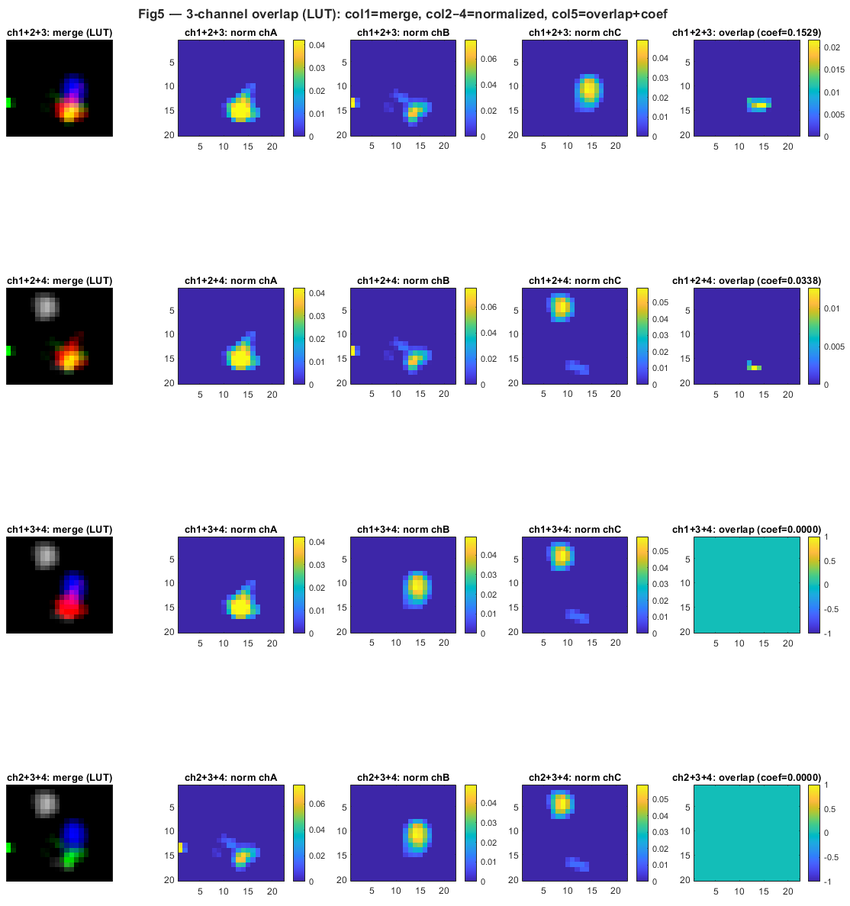
Definition of Overlap Coefficients
For each channel $X$, intensities are normalized such that:
$$∑X=1$$
Pairwise overlap
$$\text{overlap}(X,Y)=∑min⁡(X,Y)$$
Triple overlap
$$\text{overlap}(X,Y,Z)=∑min⁡(X,Y,Z)$$
This definition captures intensity-weighted spatial co-occurrence, analogous to Manders-type metrics but extended to multi-channel comparisons.

CSV Output Format
Each row corresponds to a single TIFF file.
Columns include:
- coef12, coef13, coef23, coef14, coef24, coef34
- coef123, coef124, coef134, coef234
Missing values are filled with NaN to ensure consistent table structure.

Notes on Reproducibility
- No manual thresholding or ROI selection is used
- All processing steps are deterministic
- Visualization and quantification are derived from the same underlying data
- The pipeline is suitable for batch-level statistical comparisons across experimental conditions

Typical Use Cases
- STED or super-resolution colocalization analysis
- Multi-protein synaptic organization studies
- High-throughput comparison of molecular overlap across genotypes or treatments

